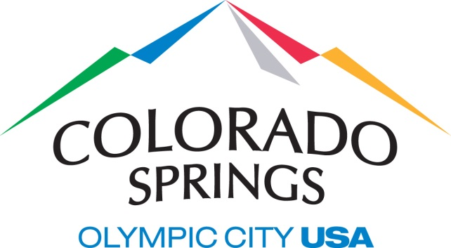

AGENDA
Public Art Commission Work Session
Thursday, August 12, 2021, 1:30 p.m. – 2:30 p.m.
City Hall, Pikes Peak Conference Room (2nd Floor)
107 N. Nevada Ave, Colorado Springs, 80903
Telephone access 1-720-617-3426 / Access code 712 526 229#
Members of the public may attend in person or via telephone

1. Call to Order
2. Presentations and Discussions

2.A Public Art Commission Legislation & Public Arts Master Plan Implementation Work Session
Presenter Bernard Byers & Richard Sebastian-Coleman

3. Adjournment

